**SEP 788/789 – Deep Learning and Neural Networks**

Project Description

Hamidreza Mahyar

[mahyarh@mcmaster.ca](mailto:mahyarh@mcmaster.ca)

Fall 2021

Introduction

As part of the SEP 788/789 course, students need to complete one hands-on project in a group of 2-3 students. Each group should pick its project from the list below. There are two types of projects: (1) Applied deep learning projects and (2) Active open-ended research projects. Each applied deep learning project is adapted from a Kaggle competition, where a challenge (from a specific industry) for an open-source dataset is stated. Each of the active research projects is adapted from an open-ended research problem from Mahyar Research Lab (and in collaboration with UofT). Groups willing to work on this type of project may continue the project until the end and contribute to the corresponding publication.

Applied Deep Learning Projects

# Project 1: Music generation

Source: [Music Dataset](https://github.com/umaniamir/music_dataset)

Description

Machine learning has covered almost all the industries where it has helped humans to mimic human-like behavior. Additionally, there are quite a few tasks where ML algorithms are proved better than humans where humans have physical limitations to achieve the task. The music industry is also not left behind. A few efforts are going on where AI and ML have improved the overall music experience by auto-generating music, correction of music notes, retrieval of information from music, etc. Here, the Music generation task is evaluated to generate beautiful music that has never been played before.

This dataset contains excellent, peaceful music from a piano that everyone likes. Here, the task is to generate beautiful music that has never been played before using deep learning approaches. The dataset contains two objects, notes, and chords. This project aims to train this dataset to create a model that predicts music from random notes and chords.

Dataset is split into two components: chords and notes. You need to use the music21 library to parse the mid file and get chords and notes. Notes contain pitch, Octave, and offset, and chords are containers for a set of notes played simultaneously.

More details regarding parsing data structure and organization can be found on the dataset [music21](http://web.mit.edu/music21/).

Project Outcomes

* Pre-process the data and create the dataset into trainable components.
* Evaluate various algorithms which can generate the music.
* Train a model to generate music from given random notes and chords.

# Project 2: Fake news detection

Source: [Fake news dataset](https://github.com/umaniamir/FakeNews_Dataset)

Description

Social media has provided an excellent interactive technology platform that allows the creation, sharing, and exchange of interests, ideas, or information via virtual networks very quickly. A new platform enables endless opportunities for marketing to reach new or existing customers. However, it has also opened the devil’s door for falsified information which has no proven source of information, facts, or quotes. It is really hard to detect whether the given news or information is correct or not. Here, as a part of this project, we need to detect the authenticity of given news using DL.

The dataset contains around 7k fake news, including a title, body, and label (FAKE or REAL). The task is to train the data to predict if the given news is fake or real.

Project Outcomes

* Pre-process the data to remove stop words. Stop words are the most occurring words in the language. It’s necessary to filter that out first.
* Evaluate the various algorithms which can affect best outcome
* Train a model to predict the likelihood of REAL news.

# Project 3: Visual Object Tracking

Source: [Visual Tracking Dataset](http://cvlab.hanyang.ac.kr/tracker_benchmark/datasets.html)

Description

The topic of self-driving cars has been at the forefront of many legislative debates and is being included in many newer car models; Tesla, in particular, has a reputation for many car models with reliable self-driving features. One such focused area is visual tracking of the objects. Visual tracking is the ability to focus on one object that is stationary or having a movement.  The visual tracking technique is derived from humans as it mimics how a child learns. This ability progresses when a child visually follows people or objects and later learns to move eyes instead of the head. This technique is helpful to derive the relation of an object with respect to the environment, Object detection, coordination of different tasks, etc. Visual tracking is quite an enjoyable task considering the number of objects in the field of view (FOV) of the camera. This project is about tracking an object into the field of view using any DL methods, benchmark the dataset, and identify the best metrics that can efficiently track the object.

This dataset contains sequences of images from recent literature that have one or more objects in it. If more than one kind of object is available, the dataset should contain identifier+’.’ +id_number. For example BlurCar.1 BlurCar.2.

See more information at the dataset [website](http://cvlab.hanyang.ac.kr/tracker_benchmark/datasets.html).

Project Outcomes

* Identify everyday objects such as cars and roads within the image
* Explore the various algorithms to track the object and find the best one.
* Train the model to track the object on the screen.
* Predict the tracking of the object using a train model.

# Project 4: Object detection for Self-driving Vehicles on adverse conditions

Source: [Object detection of Cars](http://cadcd.uwaterloo.ca/)

Description

The topic of self-driving cars has been at the forefront of many legislative debates and is being included in many newer car models; Tesla, in particular, has a reputation for many car models with reliable self-driving features. This being said, accurate image and object recognition from a live dash feed is no easy feat; when human lives and safety are involved, the proper operation of a vehicle must always be prioritized – be it by man or machine. Significant problems with these models are to cover all the possible scenarios which can occur during life. There are quite a few adverse situations that occur quite often, i.e., rain, snowfall, night images; in the dataset included in this project proposal, you will undertake the task of object detection from a car’s dash capture in various adverse situations.

This dataset provides data images of cars in various street views. The image perspective is taken from a driver’s/dashcam point of view. Each image with cars includes bounding boxes to outline the location of the vehicle in the picture. For an AI model to be used for self-driving purposes, its algorithm must achieve high accuracy and fast prediction for self-driving/real-time monitoring purposes.

Project Outcomes

* Identify/detect cars in a variety of views
* Test your trained model for accuracy and speed – can it be used on the live video feed and allow a machine to react to high-speed, real-time information?

# Project 5: ChatBot

Source: [Questions Answer Dataset](https://www.cs.cmu.edu/~ark/QA-data/?ref=hackernoon.com)

Description

Machine learning has covered almost the entire industry, where it has helped humans to mimic human-like behavior. Additionally, there are quite a few tasks where ML algorithms are proved better than humans. One such progressive area is Human Assistance. Human assistance is AI technology that can understand customer needs and provide relevant information. Many companies have started using Human assistance as Customer support systems that can reduce human efforts for satisfying customer needs. Here are a few big names in the market who use human assistance like Alexa developed by Amazon, Siri by Apple, Cortana by Microsoft, etc. ChatBot is a chat-based customer support system where AI can assist customers in providing information in their interested areas.

The dataset contains questions and answers related to Wikipedia articles. This project intends to train the Natural Language Processing (NLP) based model to provide best-suited answers from the given articles. More information about the dataset can be found on the [website](https://www.cs.cmu.edu/~ark/QA-data/?ref=hackernoon.com).

Project Outcomes

* Explore various ways that data can be trained
* Identify the best model to train the data
* Train the natural language processing-based model to predict the anonymous questions
* Predict the answers to new questions that are not part of training.

# Project 6: Lane curve detection

Source: [Curved Lane Dataset](https://xingangpan.github.io/projects/CULane.html)

Description

Autonomous driving is in boom during recent advancements where vehicles need to move safely with little or no human interaction. Quite a few efforts are going on where companies can generate advanced algorithms which can detect the objects into the driver’s live dash. For a self-driving car to function accurately, it needs to detect lanes and traffic lights related to the current vehicle and objects in the line of sight. Lane detection is one of the essential areas where precision matters the most. As a part of this project, lane detection is being evaluated, which can help make more accurate decisions during self-driving.

This dataset contains a large scale of images for traffic lane detection. It has more than 55 hours of videos and 133,235 frames. The dataset is divided into various categories like Normal, Crowded, Night, No Line, Shadow, Arrow, Dazzle light, Curve, Cross Road

For this project, you most definitely will need to read up more about the dataset on the [website](https://xingangpan.github.io/projects/CULane.html).

Project Outcomes

* Develop scenes from data and identify lanes
* Explore various computer vision and machine learning algorithms to detect lanes and identify the best met the hod.
* Use a trained model to identify lanes
* Use positional data of things within a scene to identify how off the vehicle is with respect to the center off the line.

Active Research projects

# Project 7: An Ontology-Based Approach to Visual Relationship Detection via Shape Representation

Description

Visual relationships capture a wide variety of interactions between pairs of objects in images (e.g., “man riding bicycle” and “man pushing bicycle”). Consequently, the set of possible relationships is extremely large, and it is difficult to obtain sufficient training examples for all possible relationships. This problem focuses on predicting only a handful of frequent relationships. The problem will investigate how to propose a model that uses this insight to train visual models for objects and predicates individually their appearance and their spatial relationship via shape representation and later combines them together to predict multiple relationships per image.



3 persons on 3 motorcycles

Project Outcomes

* Accurate Object Instance Segmentation, Shape Completion and Extract Spatial Shape Features
* Learn a model that combines the information obtained in the first objective using an ontology knowledge distillation framework that applies axioms that drive these relationships.

**Difficulty:** Conceptual → Moderate, Implementation → Challenging

# Project 8: Grouping of fragmented contours using convolutional neural networks (CNNs)

Description

This project’s aim is to show why perceptual grouping cues are important in both computer vision and human vision. We focus on the problem of whether convolutional neural networks are able to perform groupings on fragmented contours or not. We will investigate the role of surface closure in this task. We then create a dataset of natural scenes and line drawings of them (either drawn by artists or machines) and we look at the role of surface closure and its correlation with cues such as symmetry, proximity, good continuation, similarity, and closure of curves. We try to investigate whether there is a path in computer vision where we can connect the problem curve grouping to the problem of surface closure.

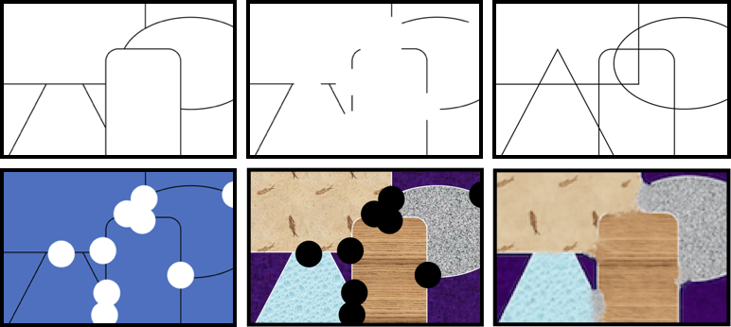

Project Outcomes

* In this project, we will design and implement a blurring equation that spreads colors from curves of interest to the regions that they are bounding and
* connect this to neural networks that can perform grouping on incomplete shapes and produce closed surface regions.

**Difficulty:** Conceptual → Moderate, Implementation → Easy

# Project 9: Unsupervised Image Segmentation with Deep Shape Prior CNN

Description

In this project, we will design and implement a convolutional neural network that accepts a fixed noise with randomized weights and tune its weights until the full test image is reconstructed. In this process, we will extract deep prior shape information from the evolved set of images while the original image is being reconstructed. The result of this project will enable us to detect a set of boundary points that separate different regions. We will use our in-house colour bleeding algorithm to reconstruct the images from the boundary in an iterative method and find the possible separating boundaries.

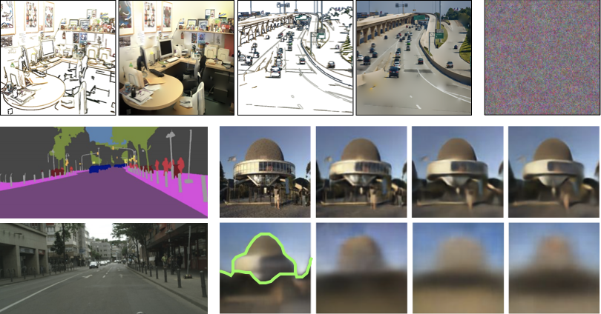

Project Outcomes

* Using any suitable image dataset, pre-process the image.
* Train the CNN model that incorporates shape to perform unsupervised segmentation on appearance images. This CNN architecture will not be dependent on any training data rather than the input image itself.

**Difficulty:** Conceptual → Moderate, Implementation → Moderate

# Project 10: Contour-guided Image Inpainting with Perceptual Grouping

Description

Image inpainting is the process of recovering content from an image with missing regions. These missing regions are represented as pixels without actual image information, and hence there is uncertainty of the content. Recently, it has been demonstrated that modern inpainting methods can be improved through guiding the inpainting models with added geometric constraints found that by adding a “guide” to show where there is a boundary between regions of distinct image content, the inpainted images are rated as more similar to the intact images by human observers. Humans are excellent at perceiving illusory outlines. We are readily able to complete contours, shapes, scenes, and even unseen objects when provided with images that contain broken fragments of a connected appearance. In vision science, this ability is largely explained by perceptual grouping: a foundational set of processes in human vision that describe how separated elements can be grouped. In this project, we want to use perceptual grouping as a guide to generate contours that will serve as guidance for inpainting models.



Project Outcomes

* Explore the various algorithms which can be used to inpaint
* Train Inpainting generative models to use perceptual grouping motivated cues computed implicitly and produce plausible inpainting results.

**Difficulty:** Conceptual → Challenging, Implementation → Challenging

# Project 11: AOF Skeletonization Package for Python

Description

The medial representation describes an object as a set of the singularities or quench points of the grassfire transform computed from its boundary. Within the object, the loci of medial points form curves about which the outline of the object is locally mirror symmetric. Each point in the interior of the object is the result of collision of two distinct boundary points. The set of medial points may also be viewed as the union of the centers of the spheres that touch the boundary at two or more locations. In other words, a medial axis consists of a set of points lying inside the boundary of an object that are equidistant to two more points on its boundary. Medial axes are used in various applications in Computer Vision and Medical Imaging.

In this project, we are going to take the *existing concept and implementation of the 2D and 3D AOF skeletons* and make it a readily installable pip package in python. Most of the codes need for this project are already available and the project will focus on preparing the existing pieces as a software that could be widely used by the community.



Project Outcomes

Ready to use python packages to extract 2D and 3D medial representations of binary shapes, and objects. The package should be able to run on various types of inputs. Produce distance map, AOF map, object angles, and reconstructions that are derived from the medial axis representation as well the medial axis itself.

**Difficulty:** Conceptual → Easy, Implementation → Easy

# Project 12: 2D/3D Topology Matching using Medial Axes

Description

There are several scenarios that require the matching of two topological maps that are extracted from two environments, two shapes, two 3D objects and/or two 3D physiological parts. One of the ways to evaluate the robustness of a representation algorithm is to start the representation from different locations in the configuration that is going to be mapped and then compare the topology maps with each other. If the resulting topology maps are not similar enough, the environment mapping algorithm needs to be revisited in terms of the stability of the representation. In applications where the shape of the subject changes, this can be used to judge whether a particular 2D or 3D representation has evolved over time. In this project, we are going to take an existing algorithm and its implementation of the 2D and 3D matching algorithm based on spectral correspondence and then do matching between topology maps of shapes and environments using AOF skeletons.

We want to show that our algorithm produces promising results, in terms of finding correspondences between similar regions, despite alterations to the graph structures themselves due to simulated sensor noise through a series of experiments.

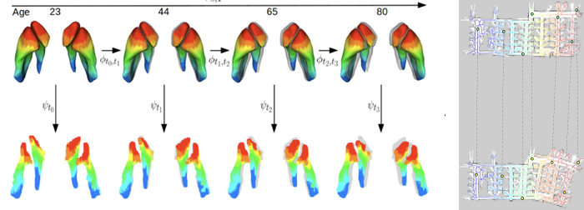

Project Outcomes

Ready to use python packages to apply spectral correspondences between two sets of shapes, objects, and environments. The package should be able to run on various types of inputs. Produce spectral graph, their correspondences, and the color visualization of those correspondences. It would be a huge plus if we integrate this in Robot Operating System (ROS) environment.

**Difficulty:** Conceptual → Moderate, Implementation → Easy

# Project 13: A Neural Representation of Line Segments from Multiple Views

Description

Shape can provide us with an extraordinary amount of information in image categorization, and thus it is important to recognize shapes from different viewpoints. Systems that are viewpoint-invariant in object detection are crucial in domains of robotics, AR/VR, autonomous vehicles and many more. Furthermore, line segments are a compact representation of objects, where they can be used to recognize objects without any texture information.  As the first part of this problem, we need to devise a learning system that is able to project the line segments into a meaningful latent space - while preserving the shape, where it’s able to predict the viewpoint. Additionally, we want to be able to generate new viewpoints of a shape.



Project Outcomes

Encode the shape of line segments into a meaningful representation. Decode the representation into the viewpoint estimates: Offset from canonical view? Predict the viewpoint of an object given an image using the feature vector. Extension: Generate a new viewpoint of the shape.

**Difficulty:** Conceptual → Moderate, Implementation → Challenging

# Deliverables

Each group should deliver:

1. Reports (15%)
   1. Explain what you have done and where you are at in the implementation
   2. Report 1: problem statement and understanding (Oct 10th, 2021)
   3. Report 2: Data pre-processing and choice of approach to implement (Oct 24th, 2021)
   4. Report 3: Explanation of the method(s) and competing approaches (Nov 7th, 2021)
   5. Final Report: Experimental evaluation and results (Dec 12th, 2021)

Note: Please submit only new content for each submission mentioned above except the final report. The final report should contain a complete report with all the content of the previous reports.

1. Code (10%)
   1. Codes must be clean, commented, easy-to-read, executable
   2. Create a GitHub repo and commit your codes there (share the link to the repo in reports)
   3. Codes will be reviewed using an AI-powered tool, so be careful plagiarism
   4. The deadline for your last commit is Dec 12th, 2021
2. Class Presentation (15%) (Dec 5th, 2021, and Dec 12th, 2021)
   1. Problem statement
   2. Your proposed approach
   3. Results
   4. Presentation

# Pick your project

Each group (2-3 students) should send us an email [mahyarh@mcmaster.ca, CC: umania@mcmaster.ca] (subject line starts with “SEP 788/789”) and rank the projects in the order you would like to work on them (e.g., a project in rank #1 is the project you would like to work on the most and the project in rank #5 means you are least interested in). Then, based on your preference and popularity distribution of projects, we will assign a project to your group.